Washington Tennis and Education Foundation (WTEF)

Arthur Ashe Children’s Program (AACP)

“Building Life Champions”

**About Us**

The Washington Tennis and Education Foundation (WTEF) Arthur Ashe Children’s Program (AACP) enhances the health, safety and academic performance of elementary school students every school year. We provide healthy snacks, academic, tennis, and life skills instruction to students after school within schools in Washington, DC’s under-resourced neighborhoods. AACP runs currently within DCPS/DCPCS school calendars. The AACP curriculum challenges students through individual and team competitions which enhance, rather than duplicate, how they learn during the school day.

**Mission**

WTEF is dedicated to building life champions through tennis and academic excellence. We work to give underserved kids a safe environment they trust and where they can excel. We empower our students to achieve their highest potential by developing meaningful values and critical life skills that will lead them to success.

**AACP Summary of Academic Core Curriculum**

AACP provides academic, athletic, and life skills instruction to children during afterschool hours, the time when statistics indicate they are most likely to participate in risky behavior. The program serves typically over 250 children living in Wards 4,5,6,7, and 8. AACP operates Monday through Thursday, 3:30 to 5:30 pm, with alternating days dedicated to academics and tennis instruction, and runs from September through mid-June, providing consistent programs and support for students from the week school starts until the week it ends.

Providing personalized attention and care to each child is at the core of all WTEF programming. The success of this strategy hinges on the quality of the AACP’s talented and engaged staff, as well as the low student-to-staff ratio. AACP enjoys 99% staff retention among both academic and athletic personnel from year-to-year, enabling staff and children to develop strong personal bonds which provide consistency, stability, and support for students. Teachers and instructors adhere to the Common Core Standards used in DC schools to ensure that program content supports what children are learning in the classroom on a day-to-day basis. AACP academic component is taught by DC Public and Charter School teachers within schools where AACP operates. Teachers are provided with guidance and support to deliver an educational component that is in concert with the student’s grade appropriate curricula. AACP teachers are familiar with students both through the program as well as through the regular school day.

Academic Core Curriculum is 4 hours per week and consist generally of the following:

* Homework assistance, tutoring, mentoring
* Math and Spelling Bee practice
* Prepare students for the AACP Academic & Life-Skills Skit Competitions

During the weeks prior to the competitions, teachers help students prepare for Academic Competitions by reviewing/studying possible math questions and Spelling Bee words. Students also increase their vocabulary and are taught to comprehend the meaning of the words they are spelling. We believe that the math, spelling, vocabulary and life skills practice will better prepare students for DC standardized testing, ACT/SAT and life in general.

**A typical day/week would go as follows (Days and Times for programming may vary)**

|  |  |  |  |  |  |
| --- | --- | --- | --- | --- | --- |
|  | Monday 3:30-5:30 pm | Tuesday 3:30-5:30 pm | Wednesday 3:30-5:30 pm | Thursday 3:30-5:30 pm | Friday - No programming |
| 3:30 – 3:40pm | Snacks and Attendance | Snacks and Attendance | Snacks and Attendance | Snacks and Attendance |  |
| 3:40 – 4:30 pm | Homework assistance & completion | Homework assistance & completion | Homework assistance & completion | Homework assistance & completion |  |
| 4:30 – 5:30 pm | Activities in preparation for Academic and Life Skills competitions | Tennis Instruction | Activities in preparation for Academic and Life Skills competitions | Tennis  Instruction |  |

**Academic Competitions**

Usually occur between November through mid-January and are comprised of math questions and Spelling Bee words that are grade appropriate. Teams comprised of students from AACP schools compete multiple times accumulating points for each victory. Those teams with undefeated records advance to the playoffs.

“The academic competitions provide a fun way to reinforce the math and reading lessons that WTEF’s students work on with their teachers. The children are learning how to make quick, smart decisions and the competition builds their sense of sportsmanship and cooperation.”

**Life-Skills Skit Competitions**

Following the Academic Competitions, AACP schools participate in the WTEF’s Life-Skills Skit Competition February through March. Weeks prior to the Life Skills Skit competitions, students are choosing themes and practicing their skits. Student discussion groups will write and perform 15-20-minute skits around themes such as “Preventing Obesity”, “Conflict Resolution” and “Stopping Bullying” with each student getting a speaking part.

They write the skits (writing, spelling), defend their ideas, discuss how to produce their team’s effort (oral explanation), design the sets (connecting visual and verbal ideas), produce the skits (integrating language and execution), and act in them (public speaking).The skits are thus a multi-faceted learning experience for the young participants designed to enhance their language skills. Students present their skits before a panel of WTEF judges.

**Tennis Instruction & Competitions**

Taught by WTEF certified coaches 4 hours per week. Coaches utilize Net Generation appropriate level curriculum developed by the United States Tennis Association (USTA) and its partners focused on play, skill and character development. Coaches prepare students for competitions April through June where the undefeated advance to playoffs. Overall champion determined in June based on results in all three categories which include Academic & Life-Skills.

Tennis is the "hook" that often initially attracts students to AACP but also what brings them back every week and year after year. AACP seeks to achieve several goals through tennis. The first is to help students learn skills on the court that translate into the classroom, including goal setting, teamwork, preparedness and good sportsmanship. The coaches also want the students to have fun while learning to play a game that can last the student's a lifetime.

**Enrichment Lesson Plans (Academic Core curriculum & Competition)**

Sample Academic Lesson Plan #1

3:30 – 3:40 – Snack

3:30 - 4:15 – Homework Help. Students without homework are to be given age-appropriate worksheets in reading or math. Teachers are to be available and helping students during the time.

4:15 – 4:30 – Clean up, bathroom break and preparation for second half of AACP.

4:30 – 5:30 – Break students into groups or pairs. Students quiz each other answering grade appropriate math questions and spelling grade appropriate Spelling Bee words with the teacher’s facilitation. Teachers also assist students with learning how to solve math questions and learning the definition of Spelling Bee words and using them correctly in a sentence.

Sample Academic Lesson Plan #2

4:00 – 4:30 – Students are transported to neighboring school to participate in Academic Competition. Students from the two schools prepare themselves for competition with a pep talk from their teacher.

4:30 – 5:30 – Students compete in the competition by standing up at the board solving math problems. Every student has multiple opportunities to answer questions during each competition. The AACP Academic Advisor and coaches deliver all questions and keep score. All schools compete a minimum of three times, with winners advancing to the final round.

Academic Curriculum Sample – 1st Grade Math Questions

1. What number come just before 100? **99**
2. A flat, or two-dimensional figure does not have depth. True or False? **True**
3. Find the sum of 15 + 41? **56**
4. Hour many hours in a full day? **24**
5. At the zoo, Kai saw 4 rattlesnakes, 1 cobra and 2 copperheads. How many snakes? **7**
6. How many tens in 43? **4 tens**
7. Jaden drew a shape with 3 corners and 3 sides. What shape did he draw? **a triangle**
8. How do you check the result of 10- 5 = 5? **Add 5 + 5**
9. What month comes just after October? **November**
10. Myles caught 7 fish. He threw back 3. How many are left? **4 (7-3)**
11. What number comes just before 40 and just after 38? **39**
12. One-third of the pens are blue, one-third black. The rest are red. What fraction are red? **One-third (1/3)**
13. Which group of numbers does **NOT** add up to 12: 3+9, 8+4, 7+6? **7+6**
14. How many months in 1 year? **12**
15. Gustavo has 9 worms. Kobe gave him enough to make 14. How many did Kobe give him? **5** (14-9=5)
16. Which number has a 9 in the ones place: 96 or 69? **69**
17. Does a perimeter go around a schoolyard or right through it? **Around it**
18. What sum do you get when you add these two-digit numbers together: 23 + 52? **75**
19. What’s another way to say “a quarter past two”? **two-fifteen (2:15) or 15 minutes after two**
20. Milan has 6 goldfish and 8 guppies. How many fish does she have in all? **14 (6+8=14)**
21. What three numbers come between 21 and 25? **22,23 and 24**
22. Whitney divided the markers in half. How many groups of markers does she have? **2 groups (or 2 halves)**
23. How much is 25 + 25? **50**
24. Maria has two coins that add up to 15 cents. What two coins does she have? **1 dime and 1 nickel**
25. Yoshi scored 2 aces yesterday and 5 today. How many more aces did he score today? **3 (5-2)**

Academic Curriculum Sample – 4th Grade Spelling Bee Words

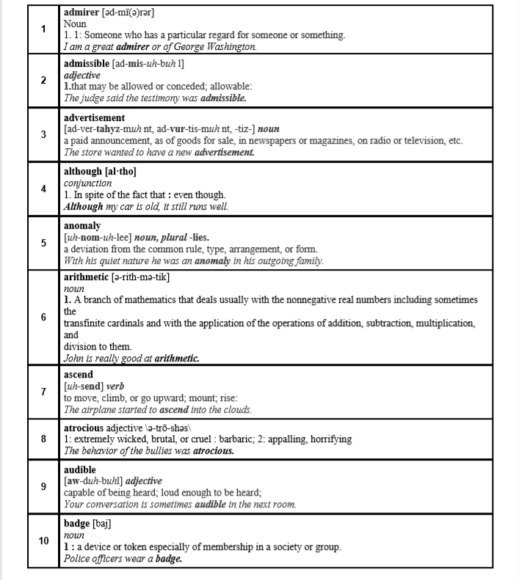

Enrichment Lesson Plans (Life Skills Curriculum & Skit Competition)

Sample Life Skills Lesson Plan #1

3:30 - 3:40 - Snack

3:40 - 4: 15 — Homework Help. Students without homework are to be given age-appropriate worksheets in reading or math. Teachers are to be available and helping students during the time.

4: 1 5 — 4:30 — Clean up, bathroom break and preparation for second half of AACP.

4:30 — 5:30 — Teacher and aids facilitate discussion about the Life Skills theme for the year. Students work as a group to write a script, design stage props and costuming for their skit.

Sample Life Skills Lesson Plan #2 — Life Skills Competition

3:30 - 3:40 - Snack

3:40 - 4: 15 — Homework Help. Students without homework are to be given age-appropriate worksheets in reading or math. Teachers are to be available and helping students during the time.

4: 1 5 — 4:30 — Clean up, bathroom break and preparation for second half of AACP.

4:30 — 5:30 — Students perform their Life Skills skit for Academic Advisor, Virginia Byrd, other judges and attending parents. They are judged on criteria outlined on the attached scoring sheet.

Life Skills Supplement Curriculum Sample (Overcoming Obstacles)

To help them with formalizing “life skills” components needed for their skits, teachers use study material and exercises from Overcoming Obstacles which is also a non-profit that publishes life skills curriculum that we utilize to enhance our programming.

Lessons cover: Being Responsible, Empathy, Coping Skills, Respect, Integrity, Having A Positive Attitude, Perseverance & Personal Best, Cooperation & Teamwork, Resolving Conflicts, Handling Peer Pressure, Becoming A Good Friend and Good Citizenship

Resolving Conflicts

Lesson Extensions

Addressing Multiple Learning Styles Extension Select a brief clip from a movie or TV show portraying a conflict between two people. Play this clip in class with the sound turned off. Have students guess the emotions that the people in the scene might be experiencing. Then, play the scene again with the sound turned on.

Art Extension: Students can make a conflict resolution fortune teller to use when faced with a conflict. (See “Conflict Resolution Fortune Teller” activity sheet for the fortune teller template.)

Drama Extension: Students can role-play scenarios where they present a conflict and then proceed to resolve it.

ELA Extension: Students can analyze a conflict faced by a character in a book the class has read. Then, the students can decide the best solution the character could have chosen. They can even rewrite the ending to a story if their “best solution” differs from the solution the character in the book decided upon.

Social Studies Extension: Find a historical instance where conflict resolution could have been used to resolve a situation.

Technology Extension: Have students identify the emotions that common emojis are used to communicate. (See “Emotional Emojis” activity sheet.) Then, have students reflect on how they feel when they receive emojis like these in messages sent from others. Have them analyze communication via text messaging and the conflicts it can create versus face-to-face communication.